JOBSHEET 7
LOOP 1

- Objective
- Students can explain the format for writing loop programs (for, while, and do-while)
- Students can implement loop flowcharts using the Java programming language.

- Practicum
  - Experiment 1: Case Study of Student Grades in SIAKAD – FOR Loop
Trial Time: 90 minutes
In the Academic Information System (SIAKAD), a lecturer inputs grades for the Basic Programming Practical course taken by students. The lecturer wants to find the highest and lowest quiz grades among 10 students in a class. The lecturer must input the grades for each student, then determine and display the highest and lowest grades. Consider the following flowchart:
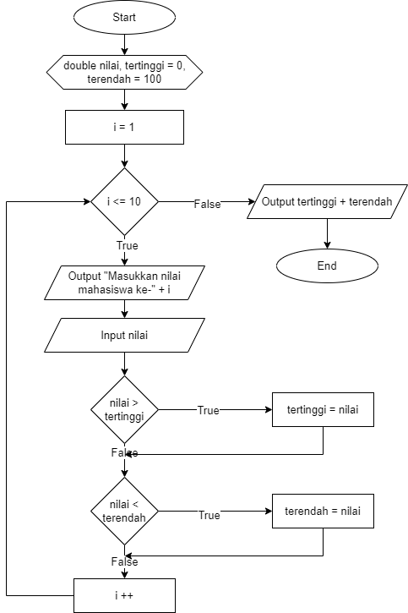
Based on the flowchart, create a program using the Java programming language.
Translated variable : nilai = grade, tertinggi = highest, terendah = lowest

- Experimental Steps
- Create a new repository on your Github account, name it daspro-jobsheet7
- Clone the repository using the git clone command from the terminal.
- Open the repository folder using Visual Studio Code
- Create a new file, name it SiakadForNoAbsen .java
- Create a basic Java program structure consisting of the main() function .
- Add the Scanner library at the top (outside) of the class
- Make a Scanner declaration with the variable name sc inside the main() function.
- Declare the variables grade, highest, and lowest using double data type. Initialize highest to 0 and lowest to 100.
- Create a FOR loop structure with a condition limit according to the number of students, 10.
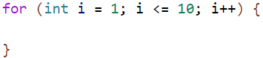
- Inside the FOR loop, add a command to enter the student's grades . Then, create two separate selection conditions to check for the highest and lowest grades by comparing the input values to the highest and lowest variables.
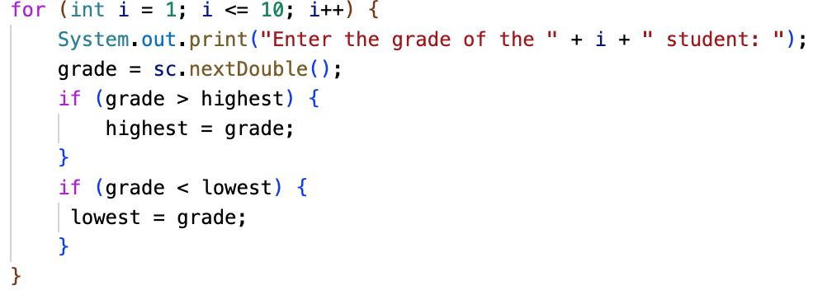
- Outside the FOR loop, display the highest and lowest values.
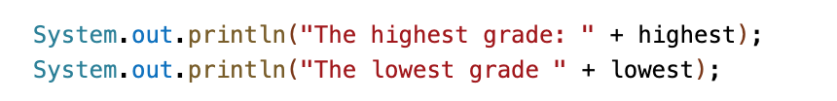
- Compile and run the program
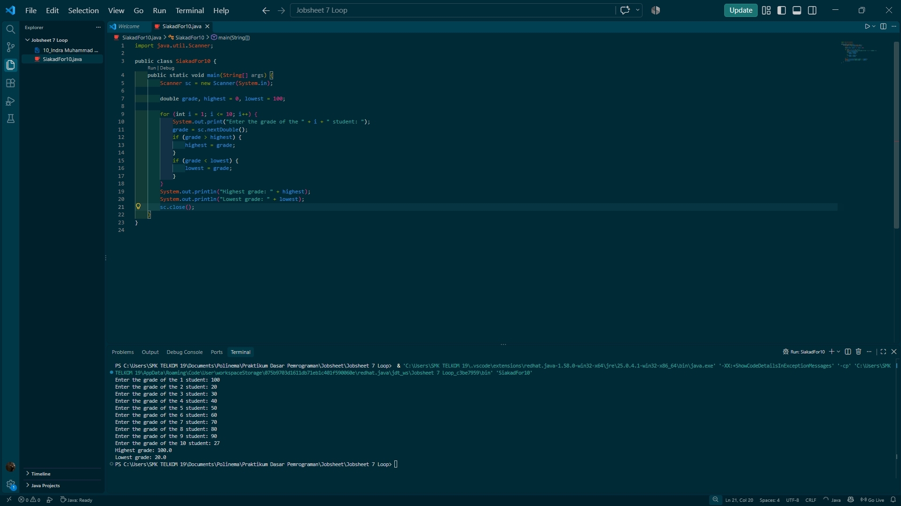
- Commit and push the program code to Github
- https://github.com/IndraMuh/jobsheet7

- Verification of Experimental Results
Match the results of compiling your program code with the following image.

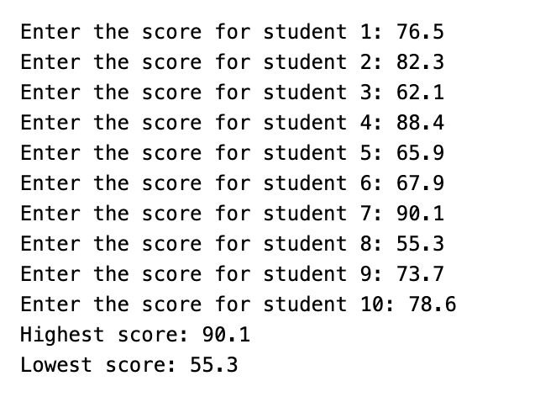
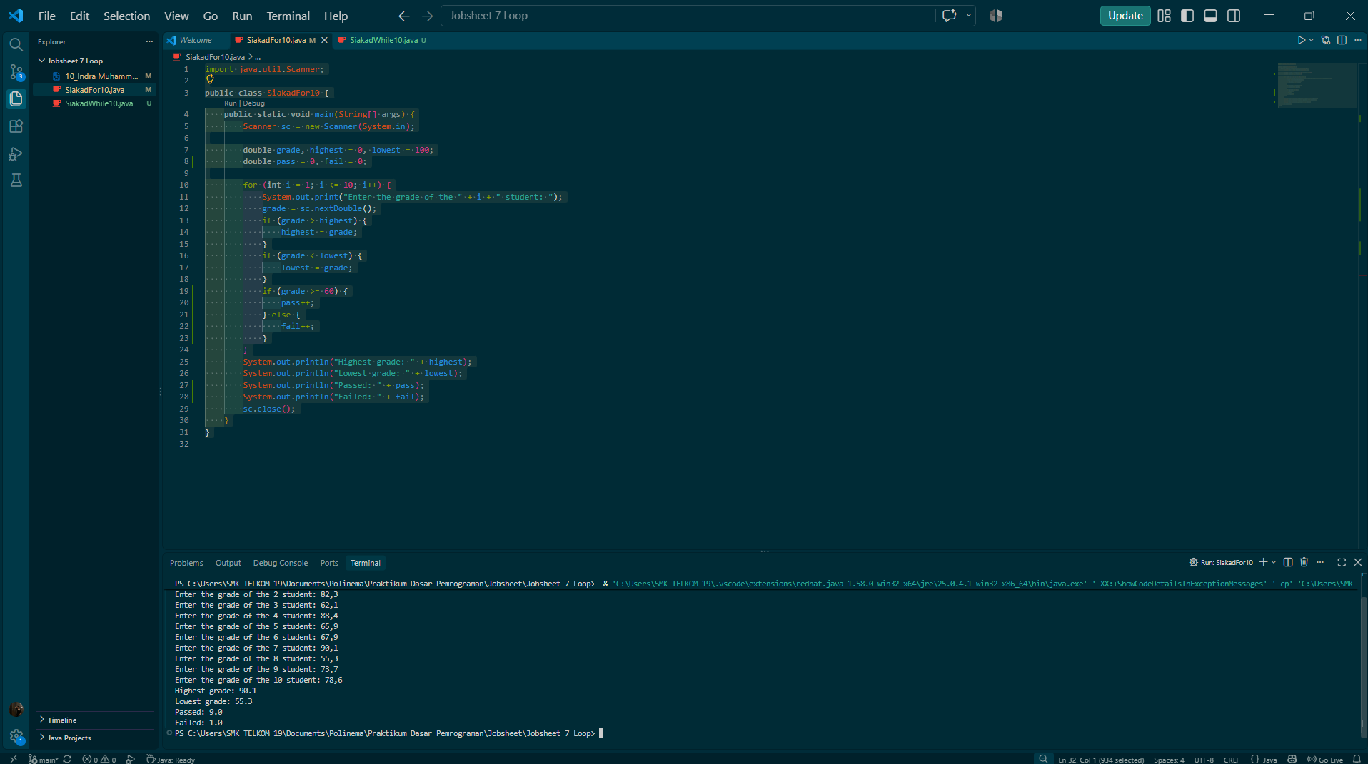
- Question
- State and show each component of the FOR loop in the program code for Experiment 1!
- Why is highest variable initialized to 0 and the lowest to 100? What happens if the highest variable is initialized to 100 and the lowest to 0?
- Explain the function and workflow of the following code snippet!
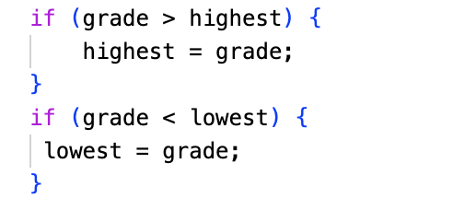
- Modify the program so that it counts how many students pass and fail based on a passing threshold (minimum grade of 60). Display the number of students who passed and failed after displaying the highest and lowest grades.
For example : add new variable pass and fail
Pass++ fail++
- Commit and push the program code to Github

Answer:
      - 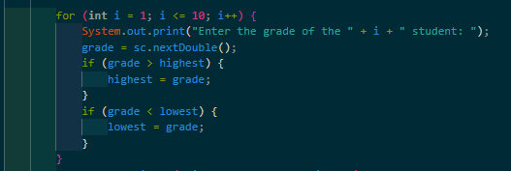
        - Initialization: int i = 1
        - Condition: i <= 10
        - Update: i++
        - Body: everything inside { } (the input and the two if checks)
      - Grades range from 0 to 100, so the starting values must be the worst possible case. Any real grade is then ≥ 0 (it replaces highest) and ≤ 100 (it replaces lowest). If you swap them (highest = 100, lowest = 0), then grade > 100 and grade < 0 can never be true. The values never update, and the program always prints Highest 100.0 and Lowest 0.0 whatever you type.
      - It runs once per student. The first if compares the new grade with the current highest and replaces it if the grade is larger. The second if does the same for the lowest. After 10 iterations, highest and lowest hold the extremes. In your run, 100 became the highest at student 1, and 20 stayed the lowest until the end.
      - 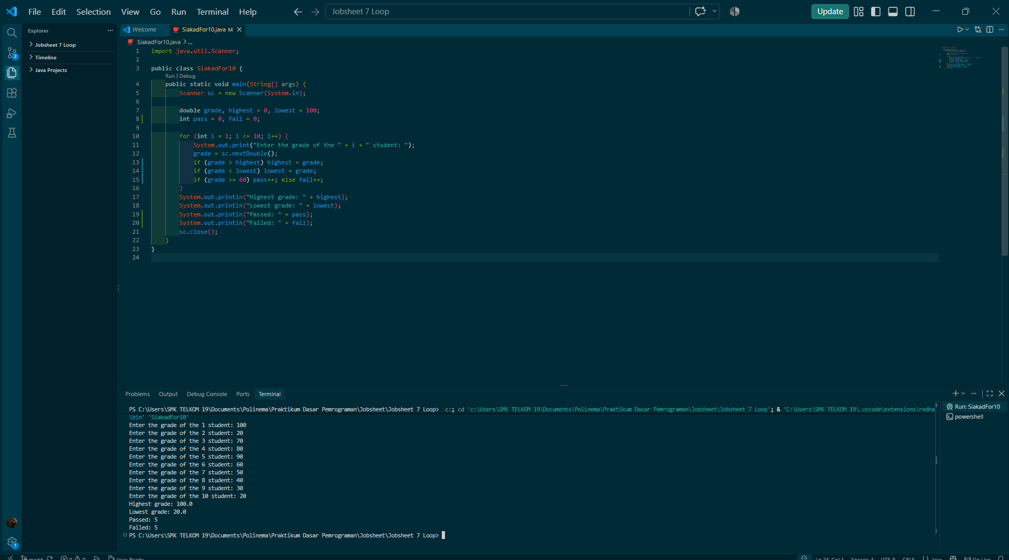

  - Experiment 2: Case Study of Student Grades in SIAKAD – WHILE Loop
Trial Time: 90 minutes
A lecturer wants to input the grades of several students into SIAKAD to determine their letter grade categories. The program must ask the lecturer to input each student's grade. If the lecturer inputs an invalid grade (negative or greater than 100), the program must ignore the input and ask the lecturer to re-enter it. Next, valid grades are grouped into letter categories A (80 < grade ≤ 100), B+ (73 < grade ≤ 80), B (65 < grade ≤ 73), C+ (60 < grade ≤ 65), C (50 < grade ≤ 60), D (39 < grade ≤ 50), and E (grade ≤ 39).
Based on the case study, create a program using the Java programming language.

- Experimental Steps
- Create a new file, name it SiakadWhileNoAbsen.java
- Create a basic Java program structure consisting of the main() function .
- Add the Scanner library at the top (outside) of the class
- Make a Scanner declaration with the variable name sc inside the main() function.
- Declare the variables grade, total, and i (for the loop) of type integer. Initialize i with 0 as the initial value of the loop.
- Write a program code to accept the number of students input, stored in the total variable . This will dynamically adjust the loop limit based on user input via the keyboard.
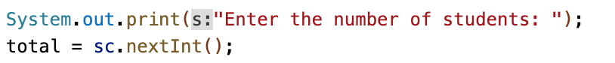
- Create a WHILE loop structure with a condition limit according to the number of students, namely 5. Note that the symbol used is < because the looping of the variable i starts from 0, not 1.
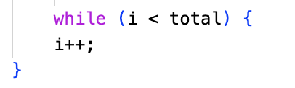
- Inside the WHILE loop, add a command to enter student grade. Next, create an IF condition to check whether the entered grades are valid, with the requirement that the grades fall within the range of 0 to 100. Then, add an IF-ELSE condition to display the letter grade categories based on the criteria.
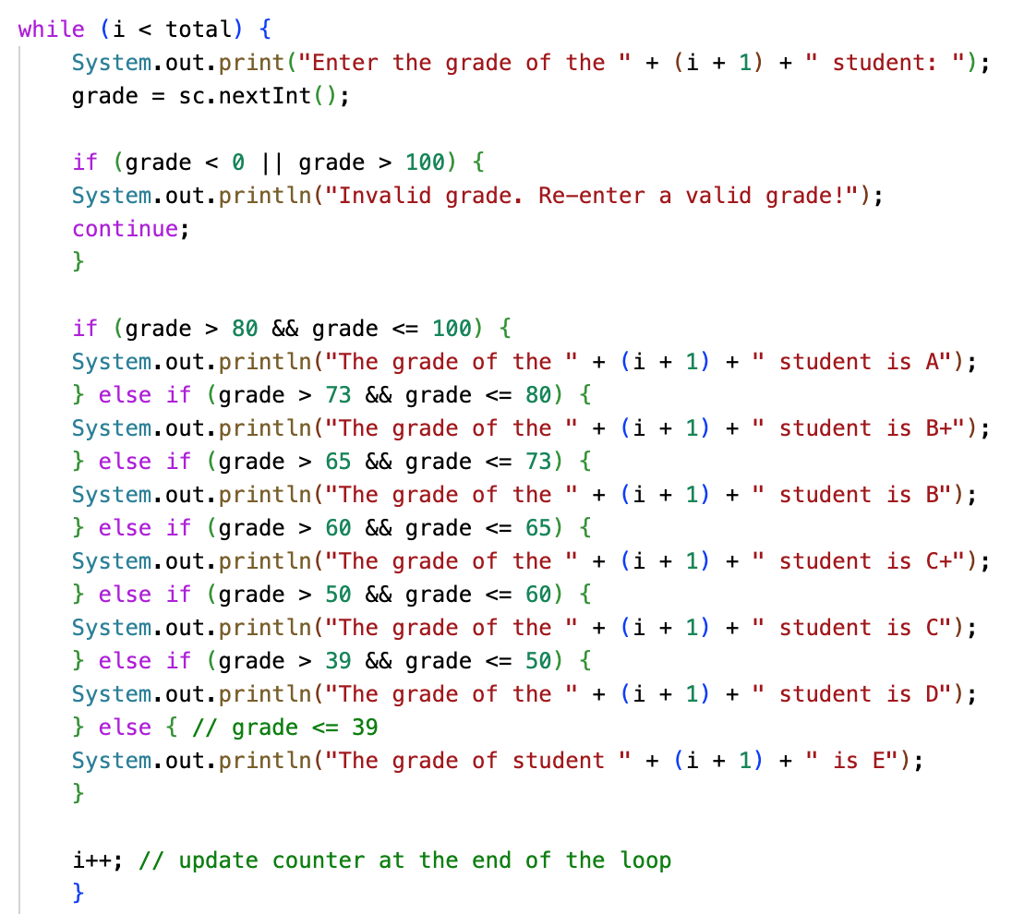
- Compile and run the program
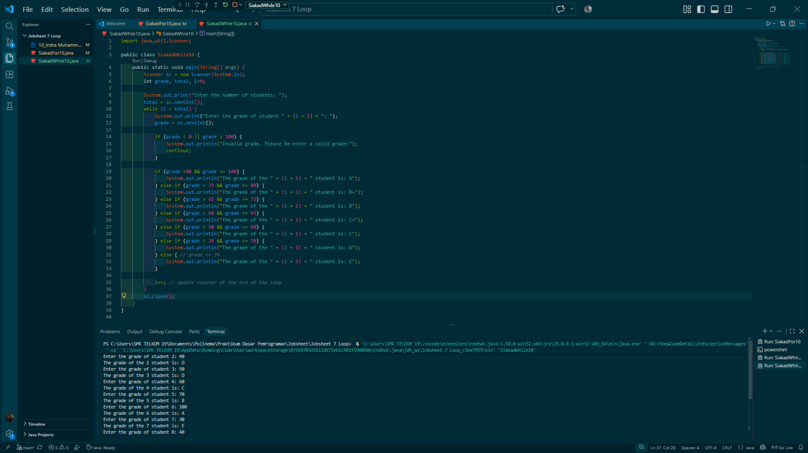
- Commit and push the program code to Github https://github.com/IndraMuh/jobsheet7

- Experimental Steps
Match the results of compiling your program code with the following image.
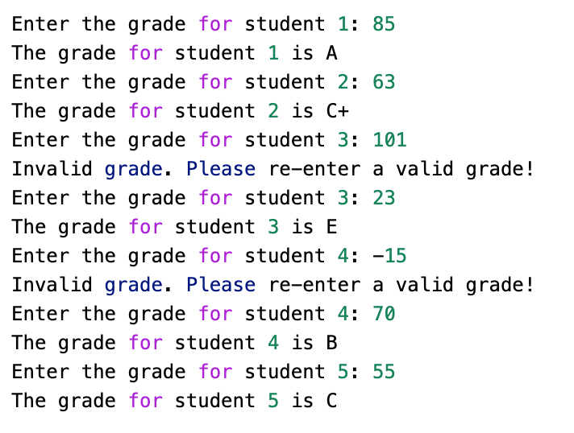
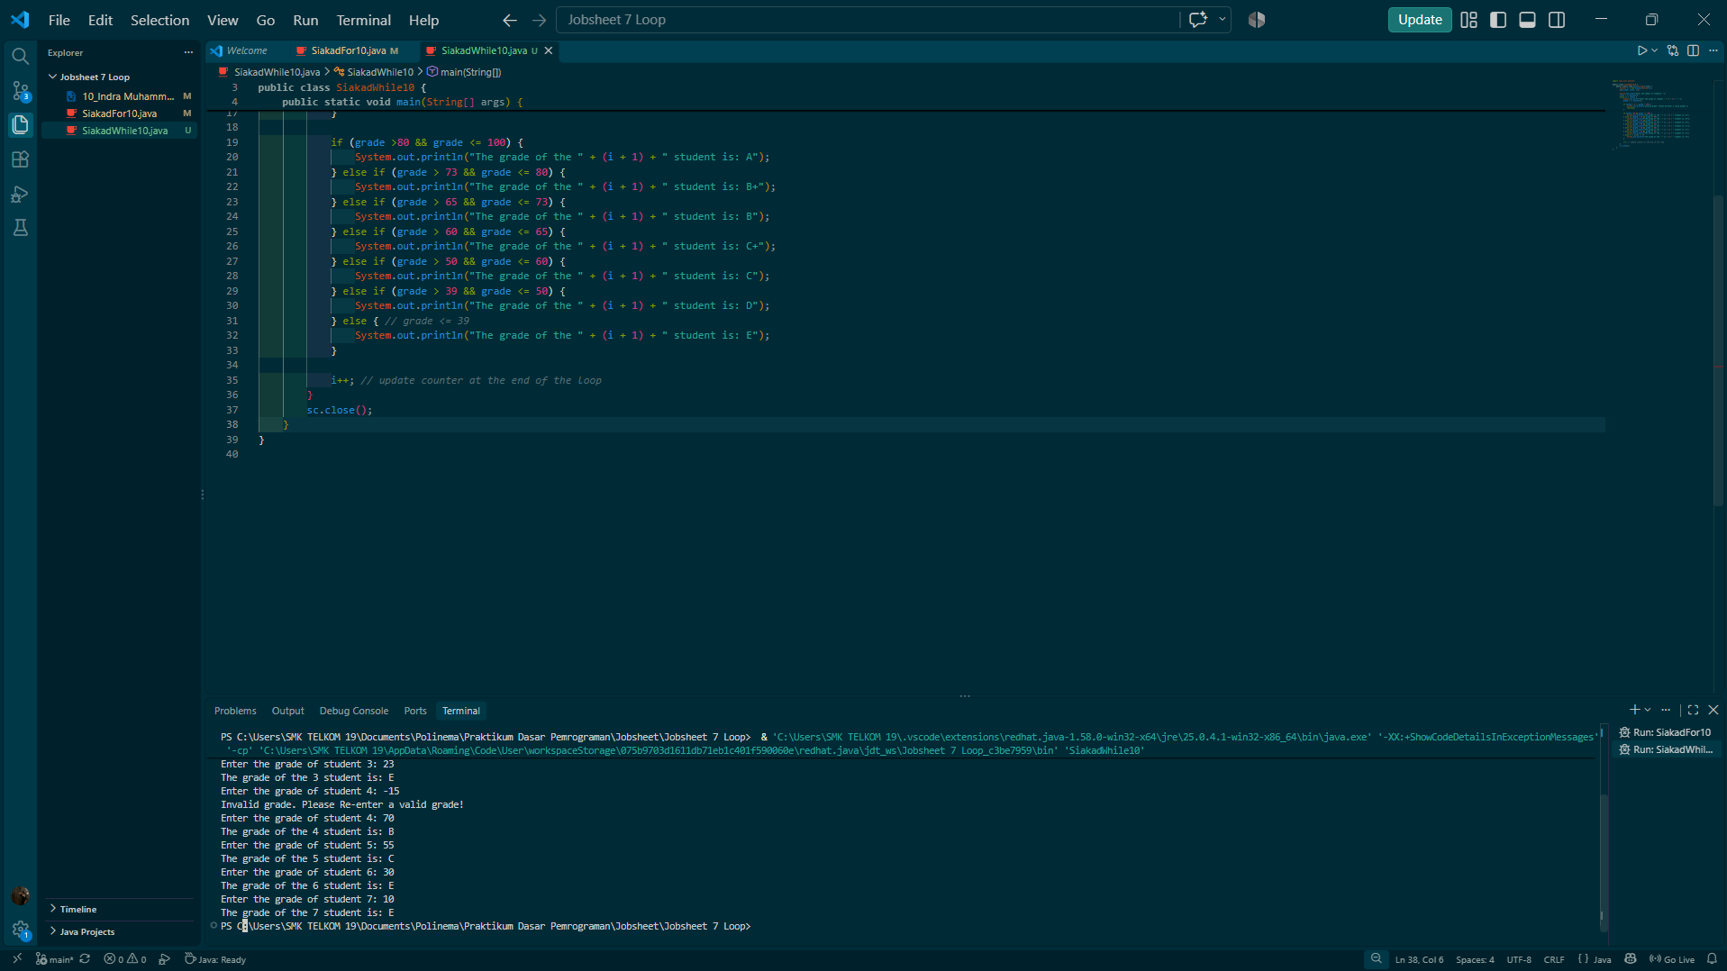

- Question
- In the following code snippet, determine the purpose and use of the following syntax:
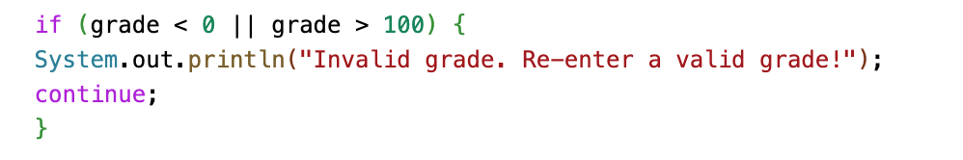
  - value < 0 || value > 100 – it is a logic operator
  - continue command to skip the rest of the loop and asking the user to enter the new grade
- Why is the i++ syntax written at the end of the WHILE loop? What happens if its position is written at the beginning of the WHILE loop?
- If the number of students entered is 19, how many times will the WHILE loop run?
- Modify the program code so that if a student gets an A, the program displays the additional message "Good, keep the grade"!
- Commit and push the program code to Github
Answer:

- grade < 0 || grade > 100: || is the logical OR operator. The condition is true if the grade is negative or above 100, which means invalid.
- continue: skips the rest of the current iteration and jumps back to the while condition. Because i++ is skipped, the same student is asked again.

- i++ should only run after a valid grade has been processed, so i counts only valid students. If it were at the beginning, an invalid input would still advance the counter. Fewer valid grades would be collected, and the (i + 1) student numbering in the messages would be off by one.
- The loop completes 19 valid iterations (i = 0 to 18). Each invalid input adds one extra pass, because i doesn’t increase for it.
- 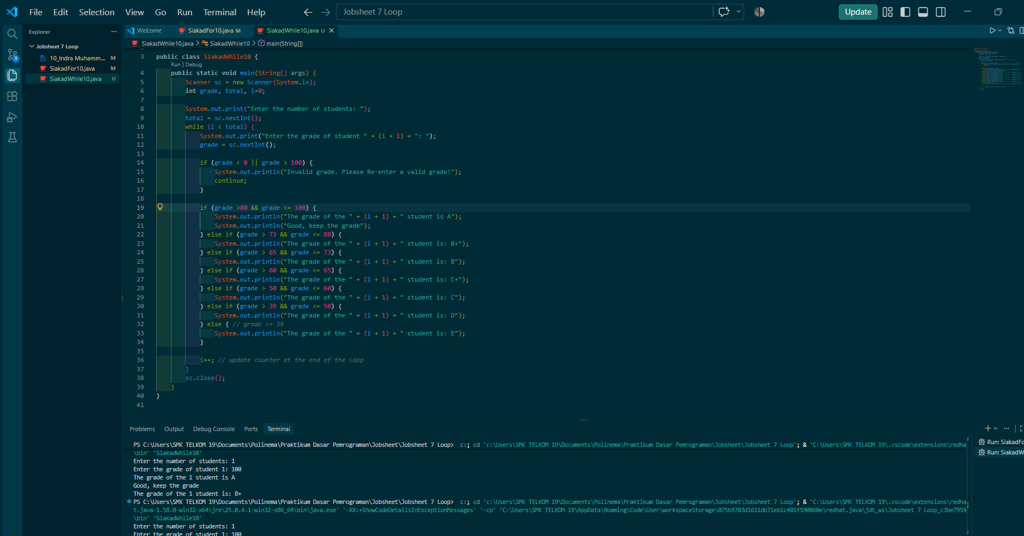
  - Experiment 3: Case Study of Transactions in a Cafe – DO-WHILE Loop
Trial Time: 60 minutes
In a cafe, the cashier wants to process transactions for several customers. Customers may purchase more than one item ( coffee for Rp 12,000, tea for Rp 7,000, and bread for Rp 20,000 ), and the cashier will continuously enter the purchase amount for each customer. If a customer decides to cancel the transaction (by entering "cancel"), the cashier will stop inputting the transaction and the program will stop.
Based on the case study, create a program using the Java programming language.
- Experimental Steps
- Create a new file, name it KafeDoWhileNoAbsen.java
- Create a basic Java program structure consisting of the main() function .
- Add the Scanner library at the top (outside) of the class
- Make a Scanner declaration with the variable name sc inside the main() function.
- Declare the variables coffee, tea, and breads of type integer to store the number of items purchased by the customer, and customerName of type String. Declare and initialize coffeePrice with 12000, teaPrice with 7000, breadPrice with 20000.
- Create a DO-WHILE loop structure with a true condition
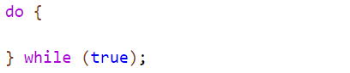
- Inside the DO-WHILE loop, add a command to enter the customerName . Then, add an IF condition to check the contents of the customerName variable . Next, add a command to enter the number of items the customer purchased for each menu item, if the customer name input is not "cancel". Calculate the total purchase price and display the result.
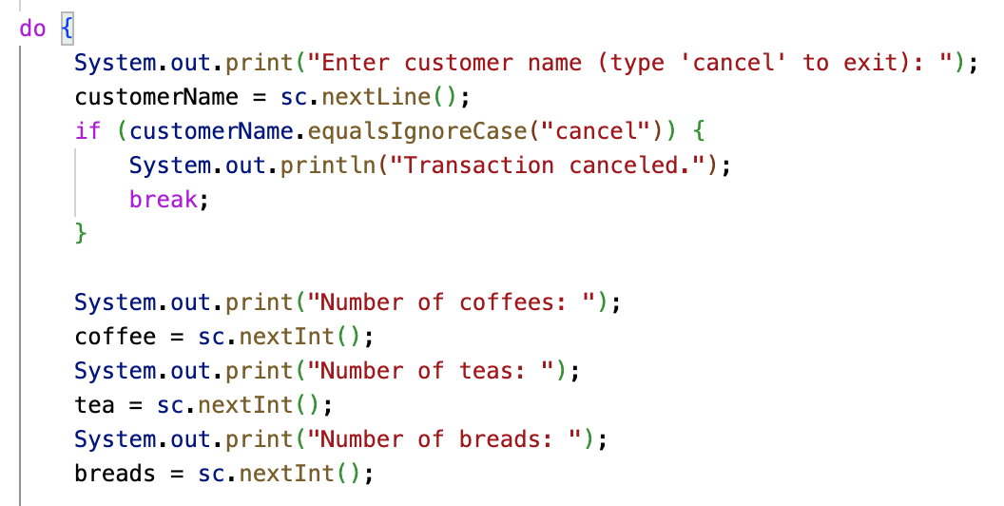

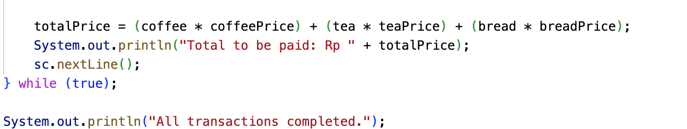
Description: sc.nextLine(); after print totalPrice is the syntax to clear newlines from the buffer.
- Compile and run the program
- Commit and push the program code to Github

- Experimental Steps
Match the results of compiling your program code with the following image.
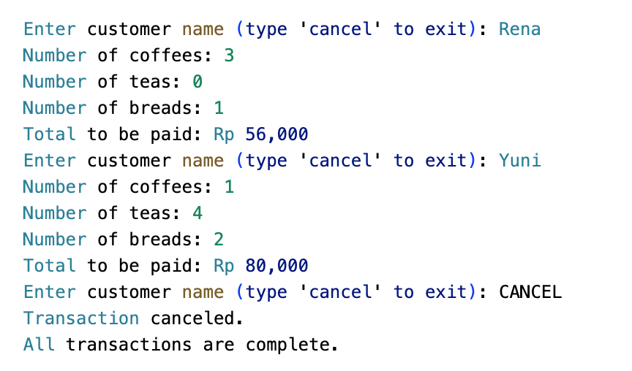
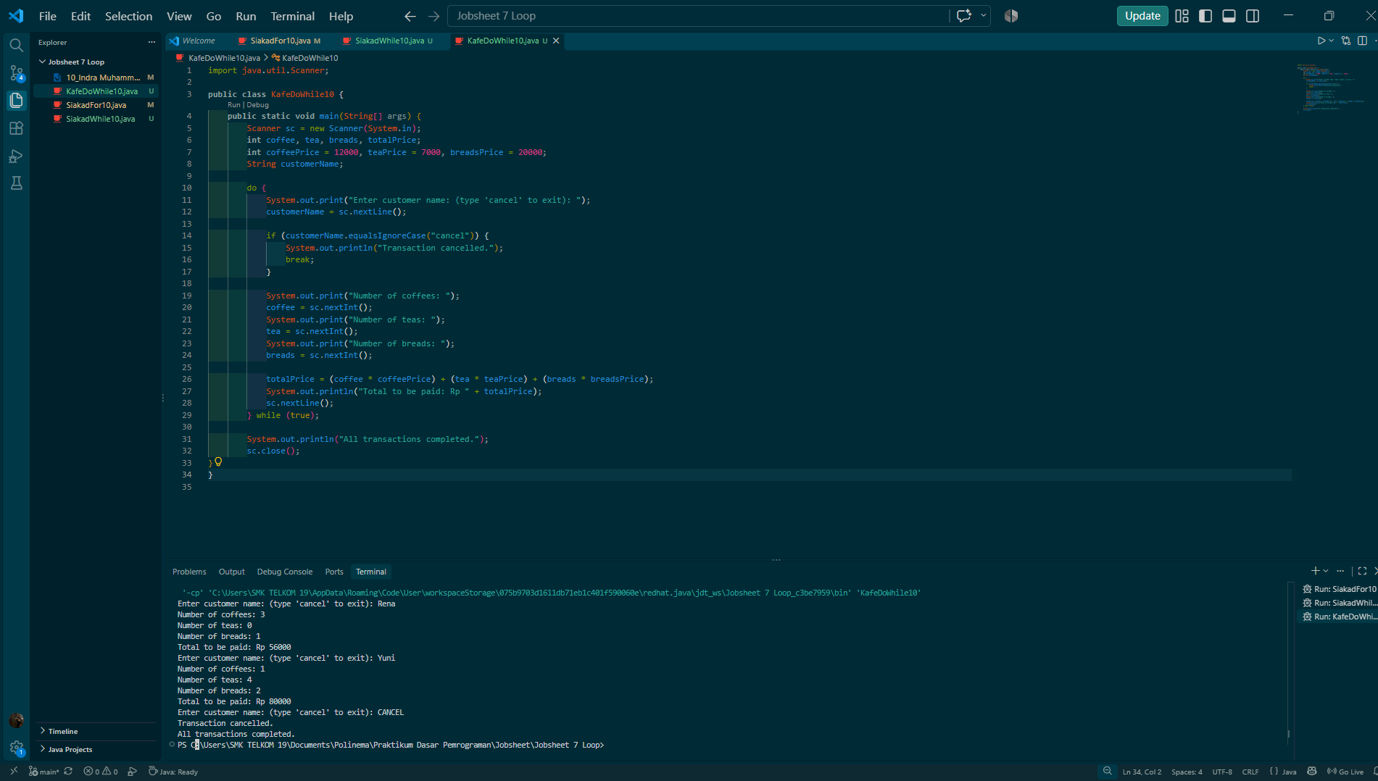
- Question
- When using DO-WHILE, if the first customer name entered is "cancel", then how many times is the loop repeated? The loop will run one time before it stops.
- State the stopping condition used in the DO-WHILE loop!
- What is the function of using the true value in the DO-WHILE condition?
- Why does the DO-WHILE loop continue to run even though there are no initialization and update components?
Answer:
- If “cancel” is entered first, the body still runs once. It reads the name, hits break, and exits. So the loop runs 1 time.
- customerName.equalsIgnoreCase("cancel"). It triggers break, so “cancel” in any letter case stops the loop.
- while (true) is always true, so the loop never ends by itself. It repeats indefinitely until break runs. This suits the cashier, who doesn’t know how many customers there will be.
- Initialization and update are only needed when the loop condition depends on a counter. Here the condition is the constant true, so no counter is involved. The exit is controlled entirely by break, not by a changing variable.

- Task
Trial Time: 120 Minutes
- A cinema manager wants to create a program to calculate total ticket sales for a single day. Tickets are sold at Rp 50,000 per ticket. The program must calculate the total number of tickets sold and the total ticket sales price for the day, with the following conditions:
  - If a customer buys more than 4 tickets, the customer gets a 10% discount.
  - If customers buy more than 10 tickets, customers get a 15% discount.
  - If the ticket amount input is invalid (negative), the program will ignore the input and ask for re-input.
Note: Loops can use for, while, or do-while statements. Add break or continue statements if necessary.

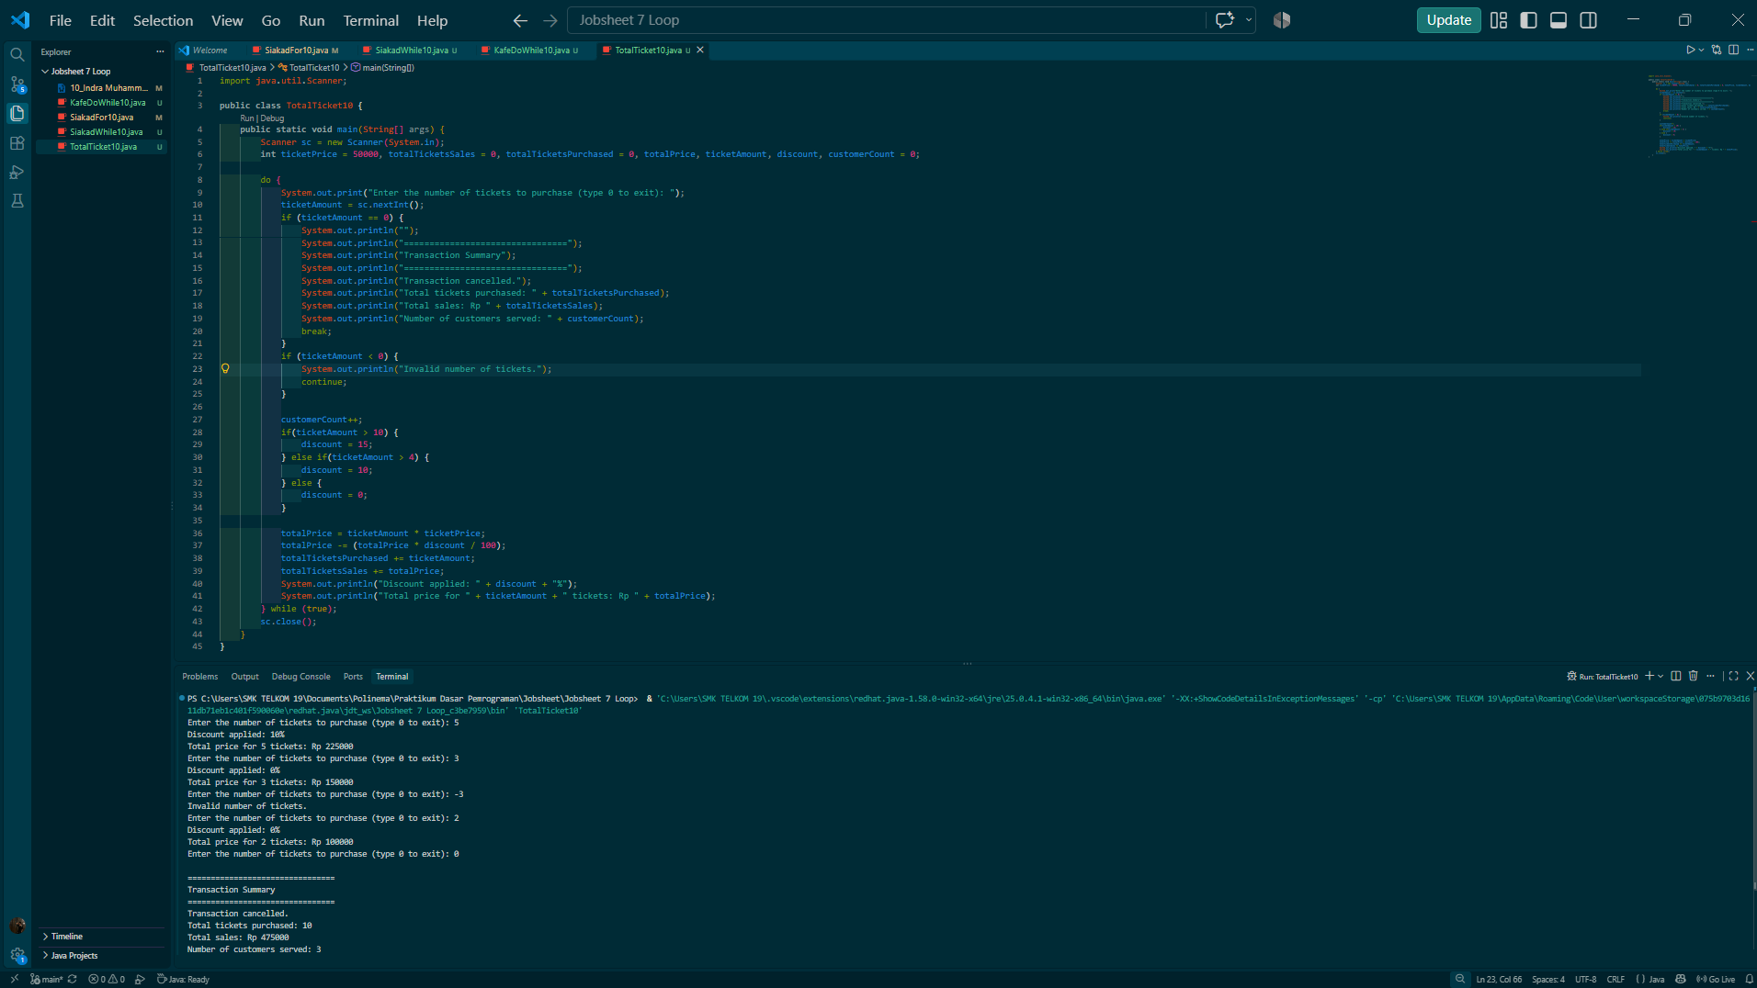
- Pay attention to the following flowchart!
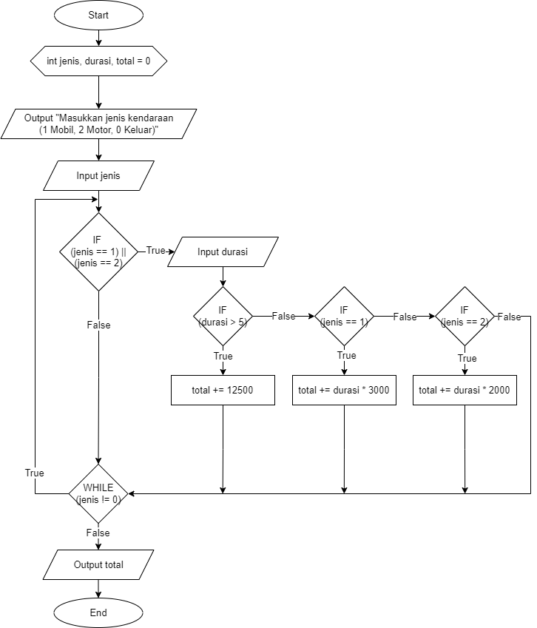
A parking lot wants to create a program to calculate the total parking fee for several vehicles. The parking rate is Rp 3,000 per hour for cars and Rp 2,000 per hour for motorcycles. However, if the parking duration exceeds 5 hours, a fixed rate of Rp 12,500 is applied to all vehicles. The program will continue to ask for input as long as the input is not 0. Implement this flowchart in Java code!

